Classic European Car - $4500 (portland)

Reply to: see below
Date: 2008-07-18, 10:06PM PDT
We have a 1966 Sunbeam Minx sedan, it has 79103 original miles on it, a BorgWarner 3-speed auto transmission, a 1725 cubic inch I4 under the hood, engine does run no problems, the tires are ok and the rims are original equipment. The interior is in perfect condition, no cracks in the seats or dash, all original parts inside, exterior is in good condition body is straight some minor dents and some door ding the chrome bumpers are in good condition body has no rust always garaged, windows are also in good condition. We have some spare parts and they will be included with purchase. This is a one of a kind collector’s item really rare to find probably won’t see many around. $4,500 is our listed price if you have any questions call us at either (503) XXX-XXXX or (503)XXX-XXXX please leave us a message with your name and a number where we can reach you.
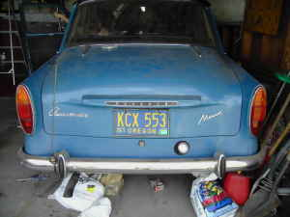 | 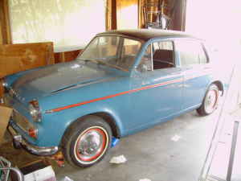
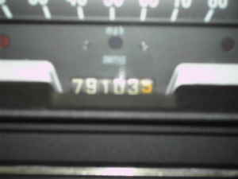 | 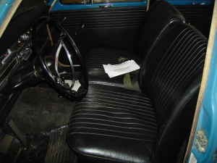

- This item has been posted by-owner.
- Location: portland
- it's NOT ok to contact this poster with services or other commercial interests
PostingID: 760926640

